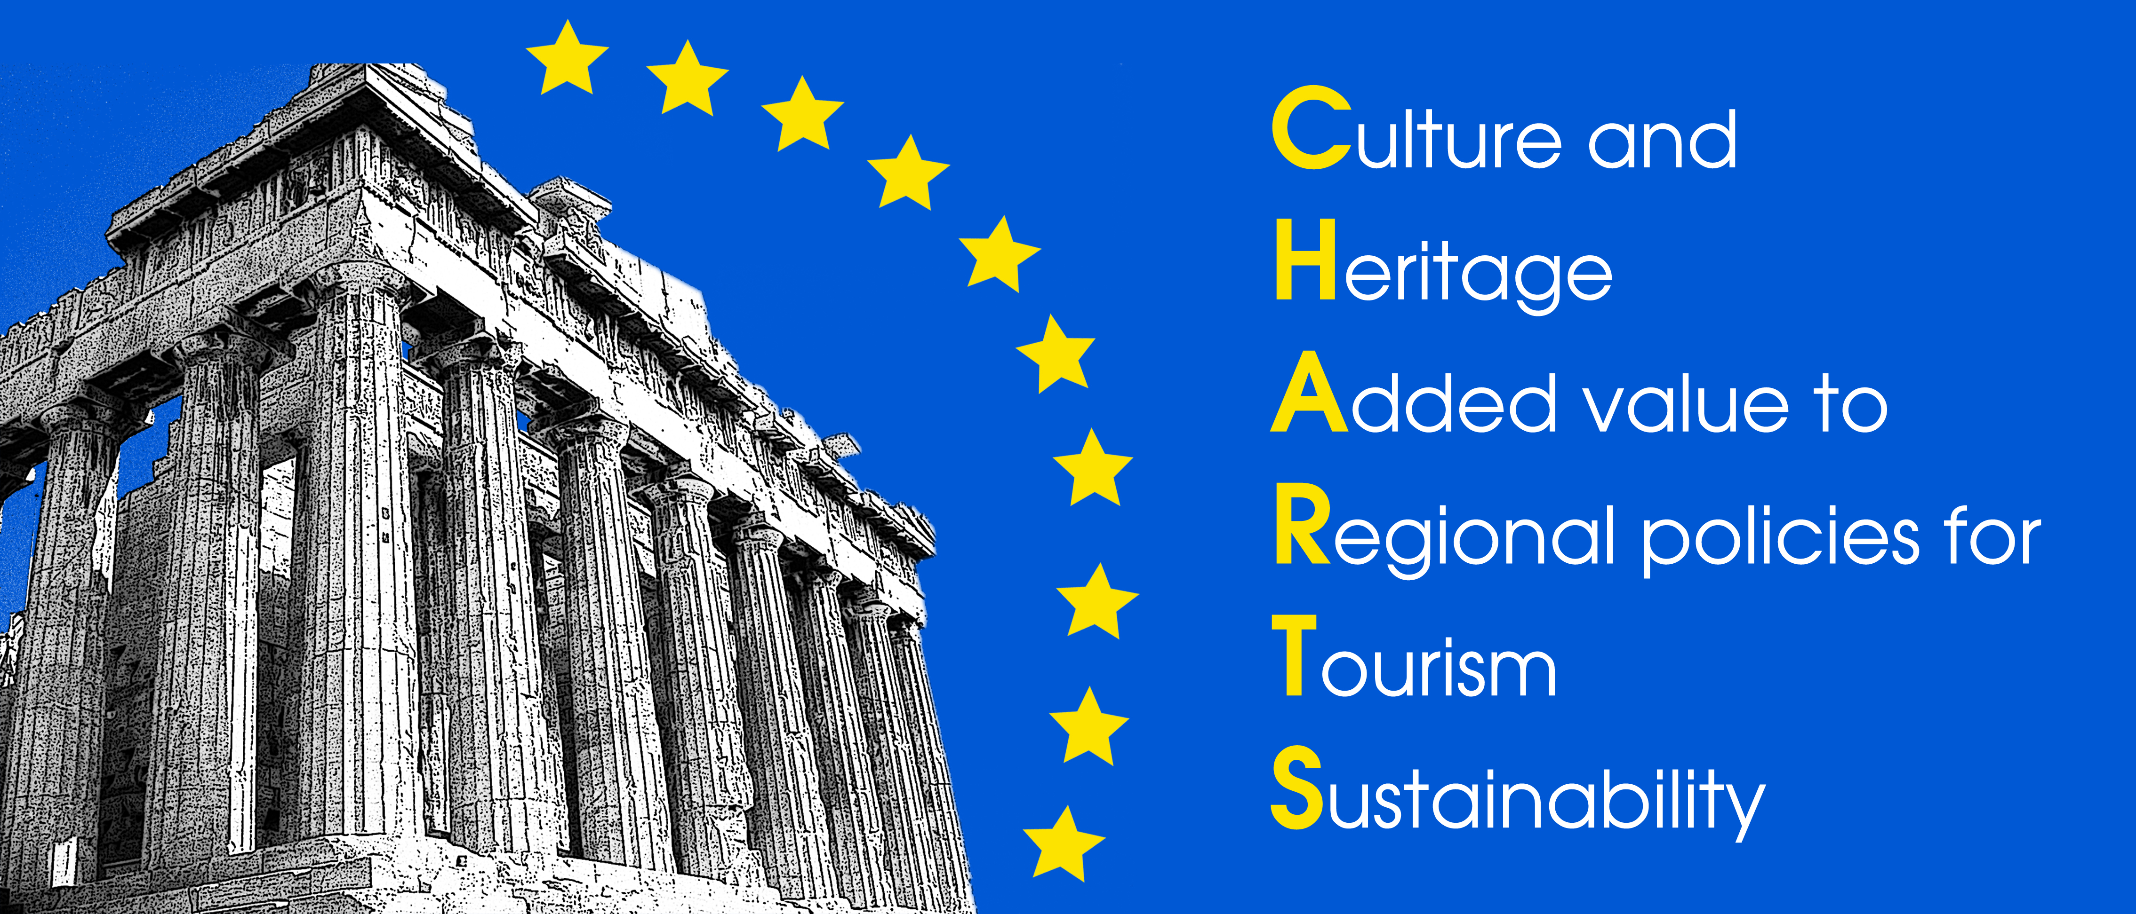

CHARTS Award 2014
The Award for Cultural Tourism Development and Promotion in Europe

APPLICATION FORM for Themes (categories)

This application form should be sent by 31 March 2014 to: charts_mcu@ymail.com and charts.mcu.ieva@gmail.com

Theme NUMBERS (at least 3)
TITLE of the Application (achievement in cultural tourism)

SUMMARY OF INFORMATION | 1.Country
SUMMARY OF INFORMATION | 2.Region
SUMMARY OF INFORMATION | 3.Tourism destination

CONTACT DETAILS | Name (title-first name-last name)
CONTACT DETAILS | Function
CONTACT DETAILS | Organisation
CONTACT DETAILS | Address
CONTACT DETAILS | Telephone
CONTACT DETAILS | Mobile phone
CONTACT DETAILS | Email
CONTACT DETAILS | Website

MANAGER OF DESTINATION – Legal representative of the destination or attraction, action, initiative | Name (title-first name-last name)
 | Function
 | Organisation
 | Address
 | Telephone
 | Email
 | Website

STATEMENT briefly

Brief Statement should cover aims of the destination, achievements and results of selected themes, partners involved, implementation, budgetary constraints, phases of development, possible findings, events, approximate total cost, and the qualities which make it outstanding in a European context.
1 page

SUPPORTING MATERIALS briefly

This section should include: * Location Plan (preferably to the scale of 1:10 000, on which the destination or site is clearly marked * Destination or site plan * documents (regional and state policies, destination latest report, statistical data, presentations (with information where and to whom was presented), video online, etc.
To complete the dossier, please, Annex or Reference to this section all supporting materials. 1 page

EVIDENCE of SUCCESS

Photographs
Good quality colour photos (up to 10) showing clearly the overall situation and important details of the submitted themes with references to sources. Photos should include BEFORE and AFTER views, preferably from the same viewpoint, laid out together in the dossier. Wherever possible, please include photos of the works in progress. All photos should be clearly captioned.

Video and documentaries
Latest video and documentaries in good quality with reference to sources of the submitted themes (online, URL added).

Promotion materials
ANNEX latest brochures, leaflets and photos of other promotional products (clips, pens, notebooks etc.).

Publication / Articles appeared in media
ANNEX scanned articles published in the media in period 2012-2014.

Communications
Social networking with references to account

